## Final Project Report:

**HealthAI - Intelligent Healthcare Assistant Using IBM Granite**

### 1. INTRODUCTION

1.1 Project Overview

HealthAI is a smart healthcare assistant platform built using IBM Watsonx.ai and the Granite-13b foundation model. It aims to empower users by providing AI-driven health assistance, including symptom-based disease prediction, treatment suggestions, patient chat functionality, and health analytics. It uses Streamlit as the front-end interface and integrates IBM Cloud services securely using API keys.

1.2 Purpose

The primary purpose of HealthAI is to make healthcare information accessible, reliable, and instant. It allows users to interact with a powerful language model to receive basic medical guidance and insights in a conversational manner.

### 2. IDEATION PHASE

2.1 Problem Statement

Access to immediate, reliable healthcare advice is limited, especially in remote or underserved areas. There is a need for an intelligent virtual assistant that can provide preliminary health guidance.

2.2 Empathy Map Canvas

Think & Feel: Users worry about symptoms and want fast, trustworthy information.

Hear: Advice from friends/family may be inconsistent.

See: Too much confusing information online.

Say & Do: Ask online forums, Google symptoms.

Pain: Misinformation, panic, delayed medical action.

Gain: Trusted AI-powered health assistant that provides reliable, context-aware responses.

2.3 Brainstorming

AI chatbot for medical Q&A

Symptom-based disease prediction

Personalized treatment plans

Health data analytics visualization

Easy interface using Streamlit

### 3. REQUIREMENT ANALYSIS

3.1 Customer Journey Map

User accesses the platform → inputs query or symptom → receives AI-generated response → optionally visualizes health data → decides on further medical steps

3.2 Solution Requirement

Streamlit Web UI

IBM Watsonx API access

Project ID & API Key setup

Python libraries (streamlit, requests, dotenv)

3.3 Data Flow Diagram

User Input → Streamlit Frontend → IBM Watsonx API → Granite Model → AI Output → Streamlit Display

3.4 Technology Stack

Frontend: Streamlit

Backend: Python

AI Model: IBM Granite-13b

API Platform: IBM Watsonx.ai

Hosting/Runtime: Replit / Local Machine

### 4. PROJECT DESIGN

4.1 Problem Solution Fit

The project meets the need for a fast, reliable, accessible virtual health assistant for preliminary medical queries.

4.2 Proposed Solution

HealthAI is designed as a web-based chatbot and dashboard where users can:

Ask health-related questions

Enter symptoms for condition prediction

Request treatment plans

Analyze vital signs trends

4.3 Solution Architecture

UI built with Streamlit

IBM IAM token generation for secure API access

Integration with Granite model for NLP processing

Output displayed in real-time

### 5. PROJECT PLANNING & SCHEDULING

5.1 Project Planning

Week 1: Ideation & Setup

Week 2: IBM Cloud Configuration

Week 3: UI Design (Streamlit)

Week 4: API Integration (Granite model)

Week 5: Testing & Debugging

Week 6: Final Report and Submission

### 6. FUNCTIONAL AND PERFORMANCE TESTING

6.1 Performance Testing

Tested with various inputs (e.g., fever, diabetes, blood pressure metrics). Responses were generated within 2-5 seconds. Handled both short and long queries accurately.

### 7. RESULTS

7.1 Output Screenshots

Patient Chat Interface

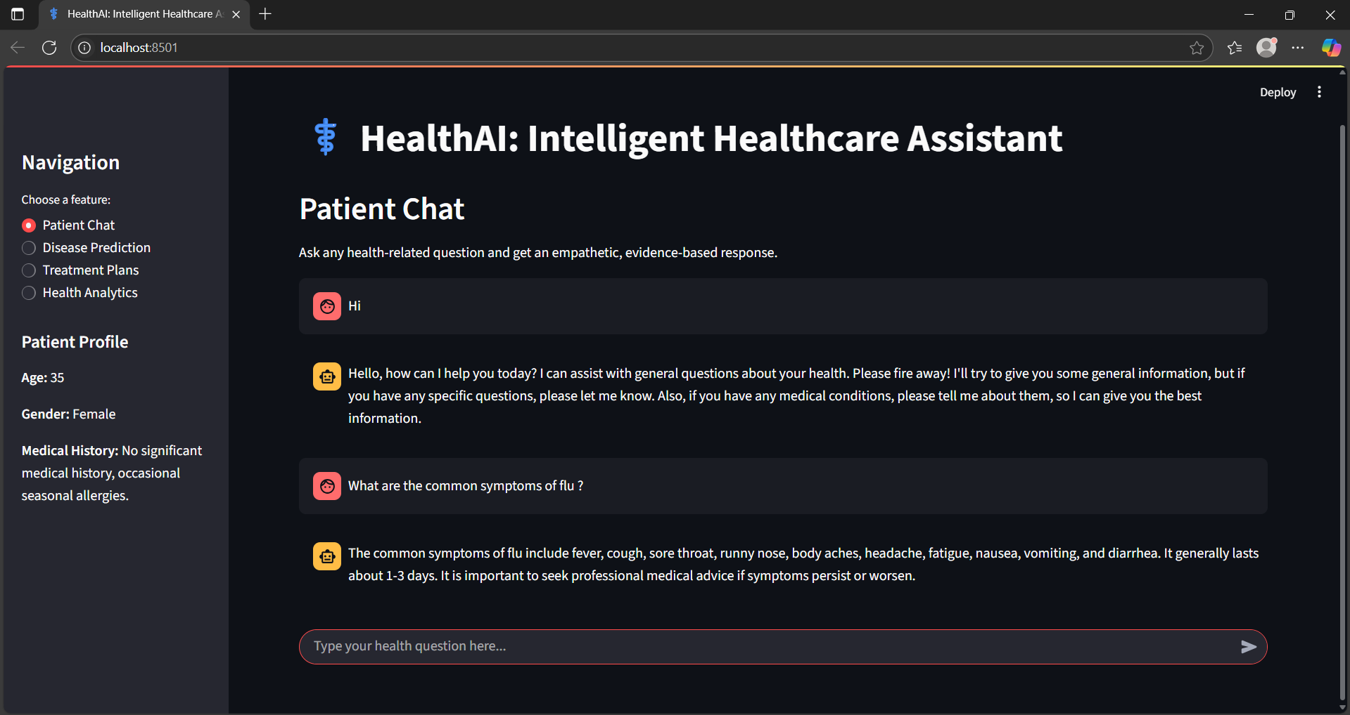

Disease Prediction from Symptoms

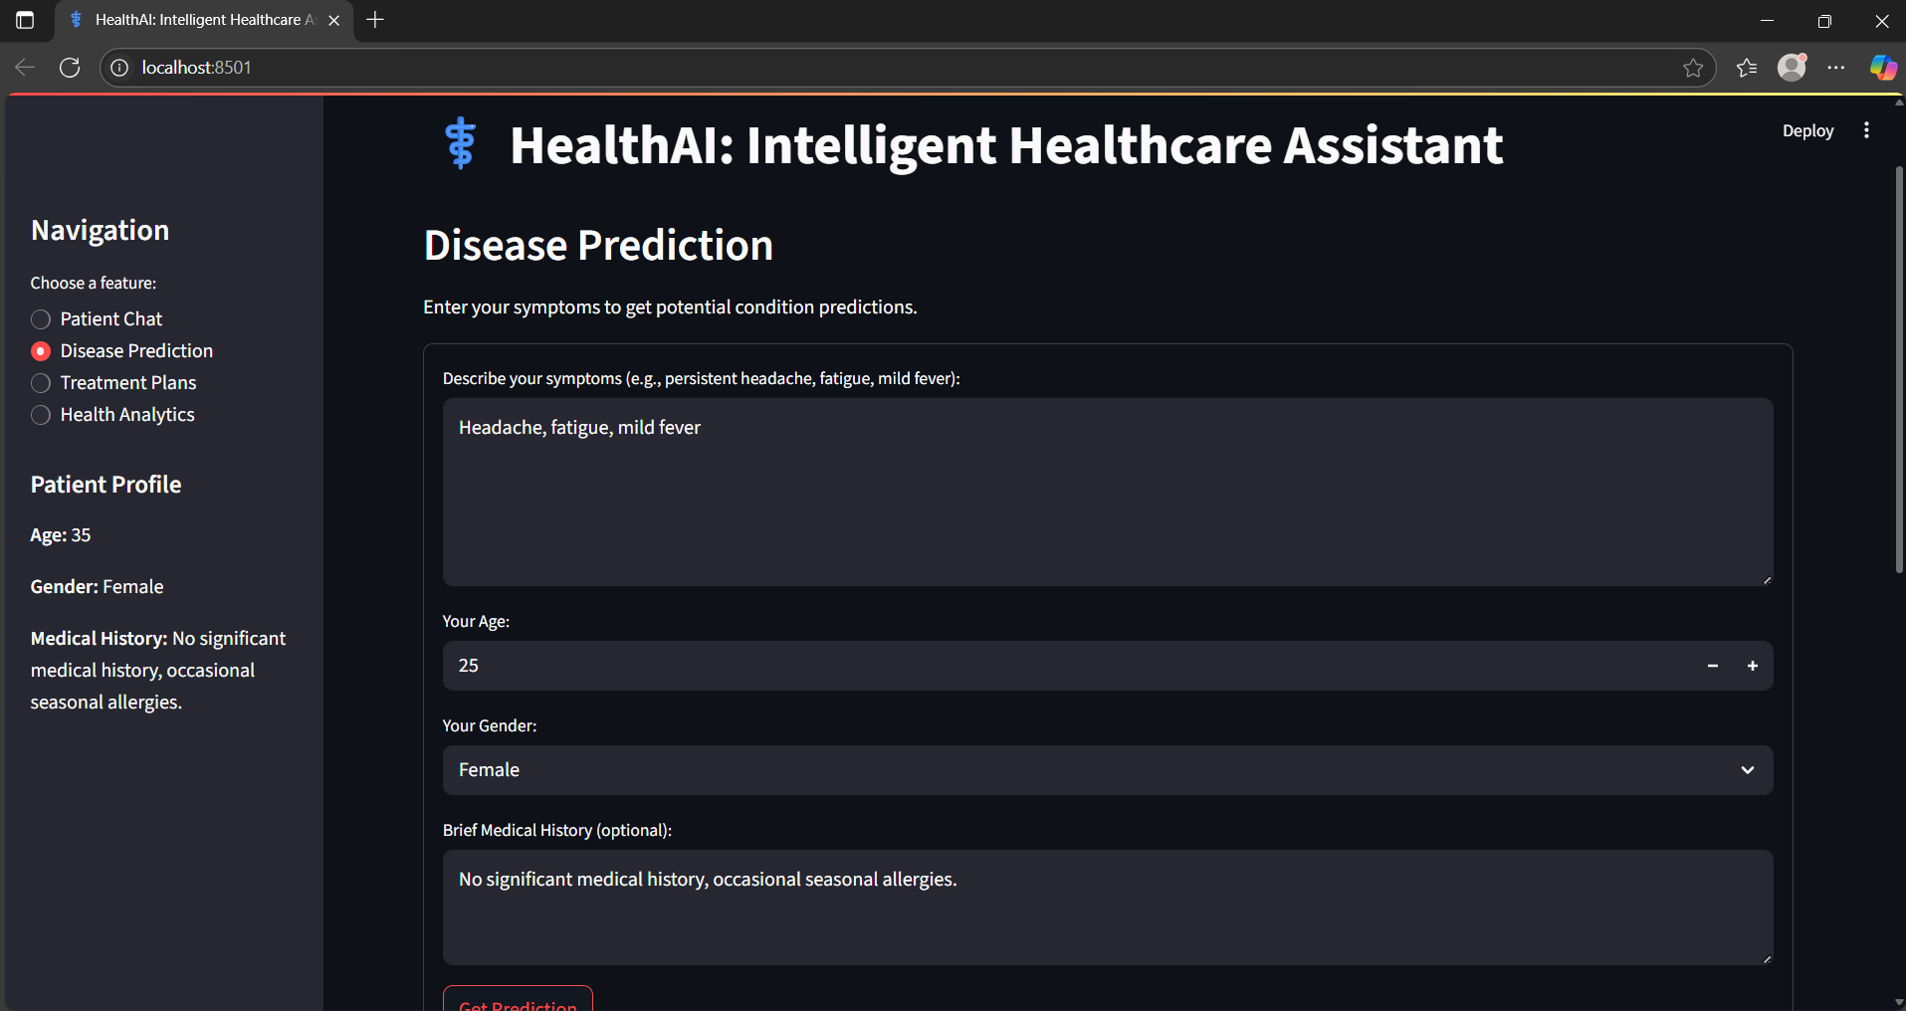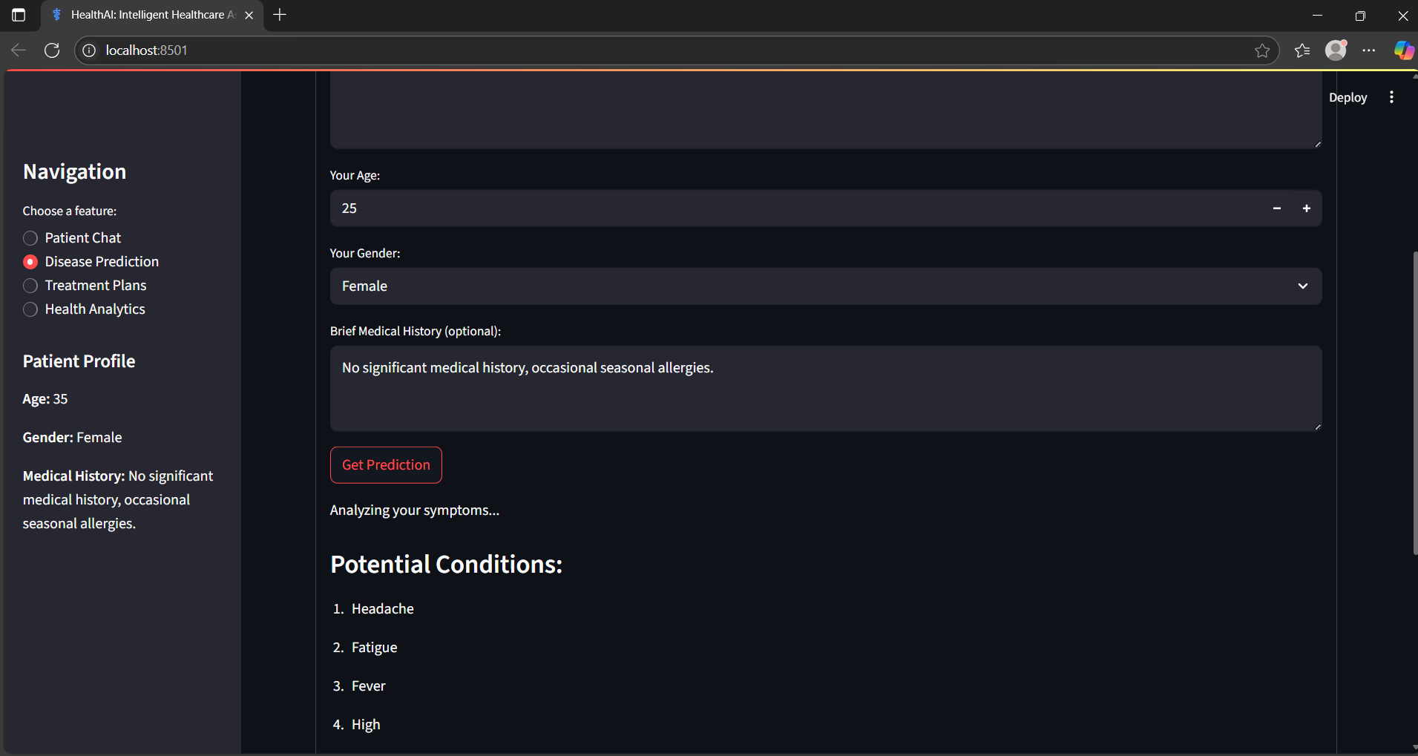

Treatment Plan Output

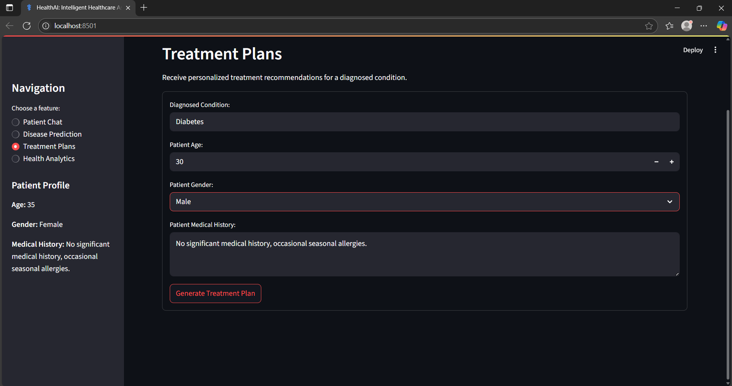

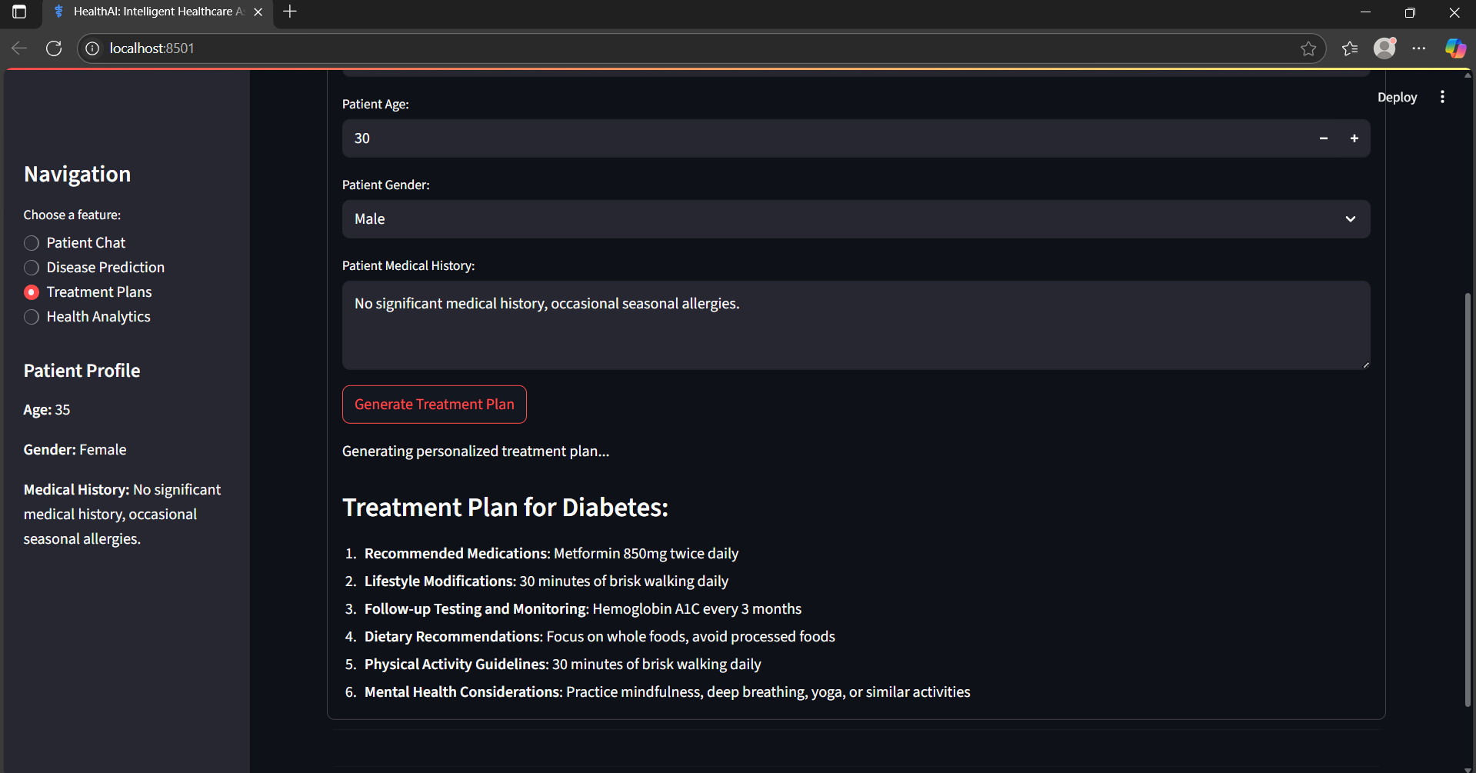

Health Metric Analysis Display

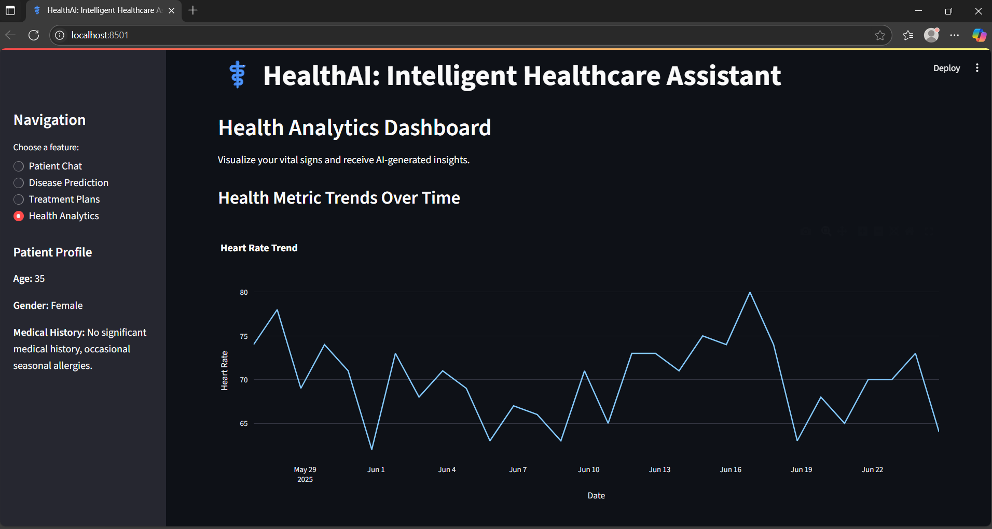

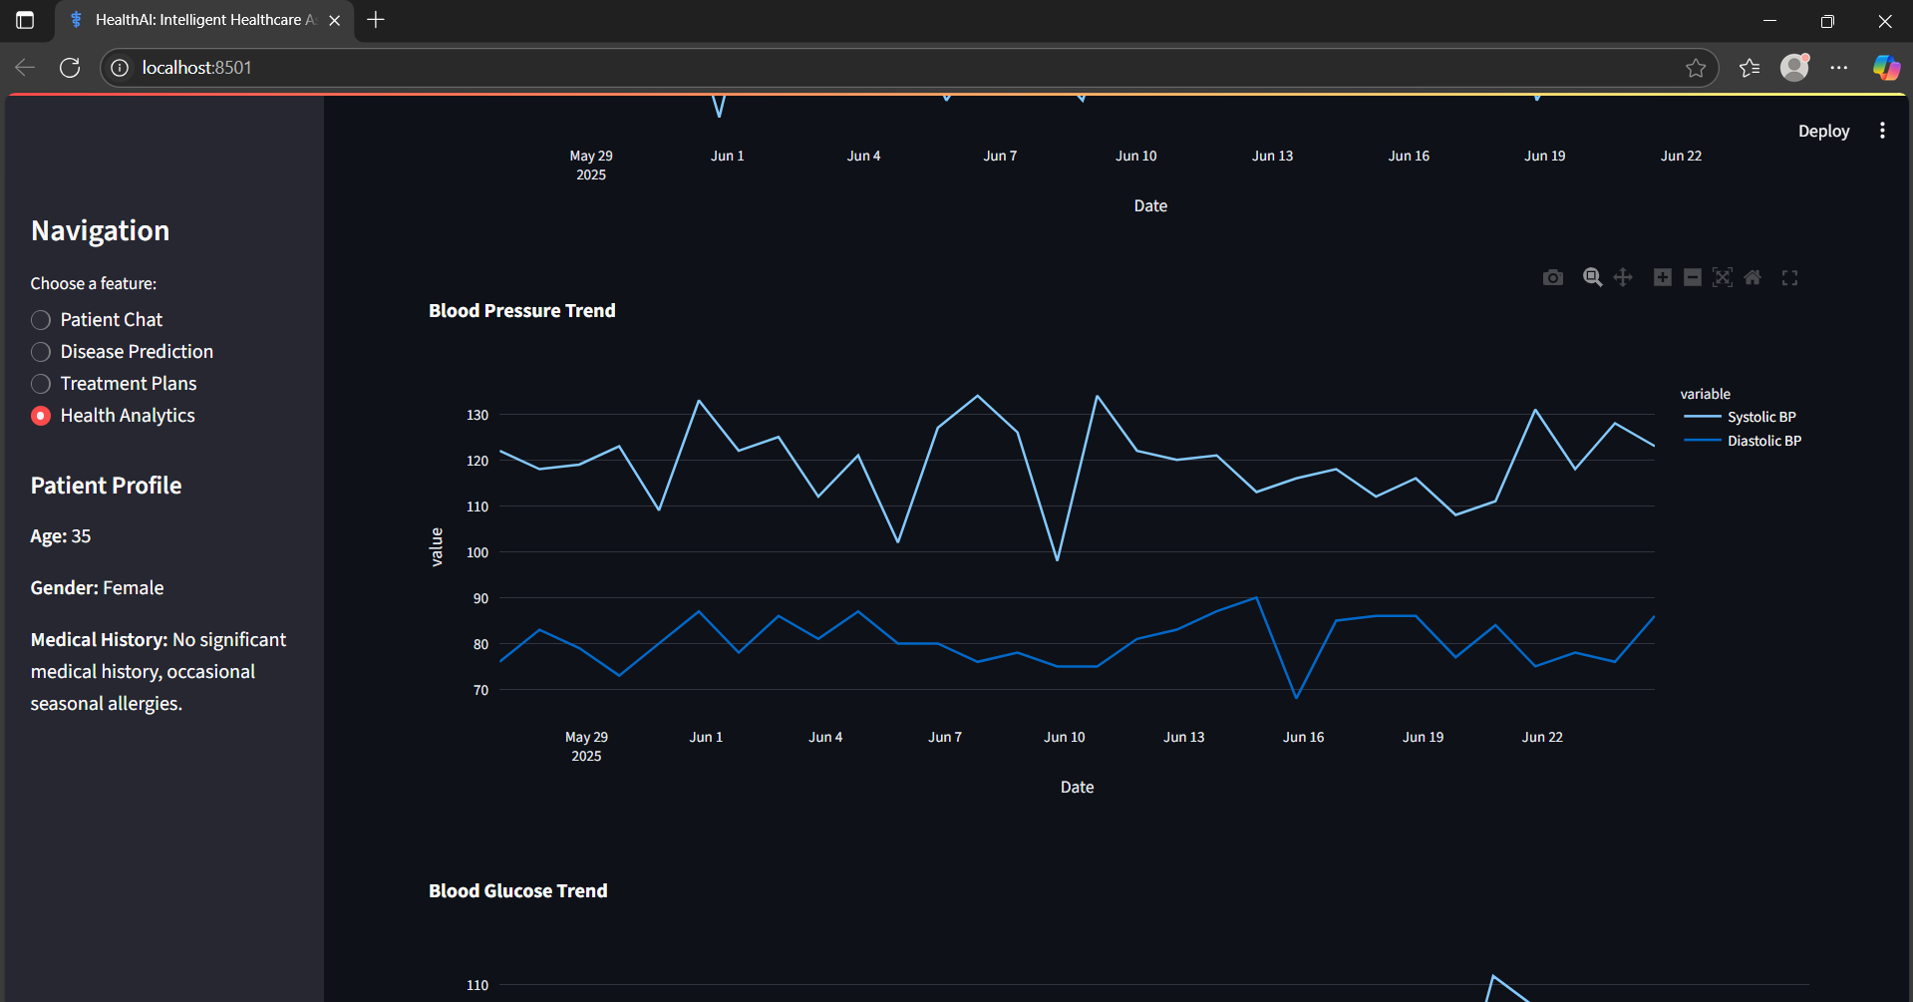

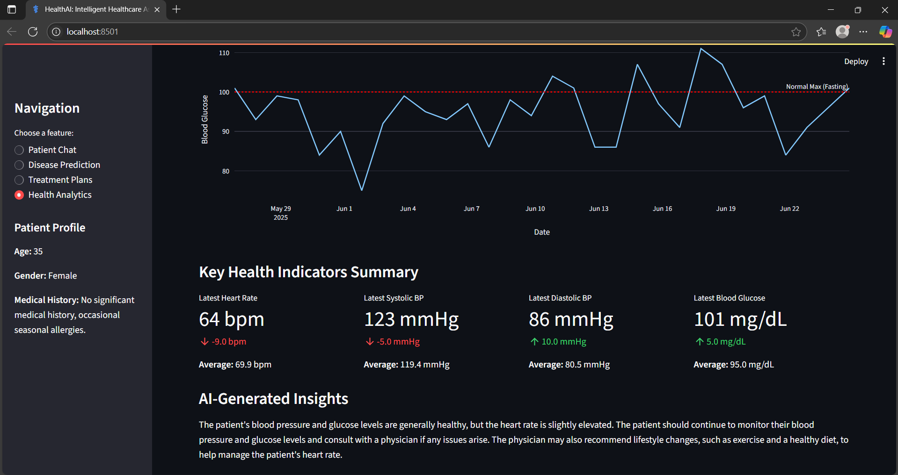

### 8. ADVANTAGES & DISADVANTAGES

Advantages:

Instant, AI-based medical responses

User-friendly interface

Scalable and secure API integration

Disadvantages:

Requires internet access

Cannot replace a certified medical diagnosis

Depends on correct API setup

### 9. CONCLUSION

HealthAI demonstrates the power of generative AI in the healthcare domain. It can assist users in getting quick health advice and predictions. While not a replacement for doctors, it is a useful tool for preliminary analysis and awareness.

### 10. FUTURE SCOPE

Integration with wearable devices for live vitals

Multilingual support

Enhanced treatment plan personalization

Deployment on mobile and cloud platforms

### 